SUDHA SOCIETY ACTIVITY REPORT YEAR 2021
SUDHA Society has been working for the welfare of the society for last many years. In these difficult times of Covid-19 Pandemic too, the volunteers have been on their toes to serve the people.
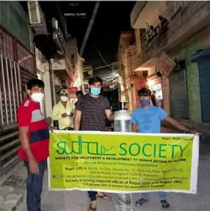
During the second week of May 2021, i.e., 9 May to 16 May, the NGO supported the Red Cross and Municipal Corporation of Gurugram in distribution of Oxygen Cylinder. Volunteers of SUDHA Society worked tirelessly day and night to deliver the cylinders at patients doorstep. This is besides the mask distribution to more than 7000 needy people in the City motivating to wear mask and wash hands regularly .

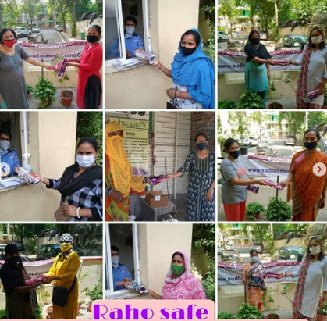
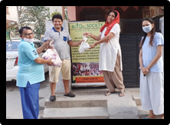
SUDHA Society celebrated 28th May, International Menstrual Hygiene Day 2021. The society took up 2 major tasks. First, Ms. Ruchi Saxena, President of SUDHA with volunteers, distributed sanitary pads to poor women and adolescents and educated them about the importance of hygiene during menstruation. Second, an awareness talk show on Menstrual Hygiene Day. The event was hosted online and was fruitful for the audience. The event was hosted by Ms. Aashima Gandhar and three panellists were present to guide the girls: Ms. Anu Sahdev, Ms. Pratibha Sharma and Ms. Sanchi. This was in continuation to the project started in Feb - since then every month Menstrual hygiene campaigns are arranged by Sudha Society.

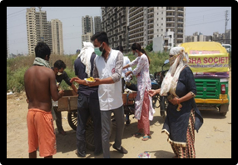
On 31 May, 2021, on the occasion of World Tobacco Day, SUDHA Society distributed dry ration to 50 poor families during phase 2 of Covid-19. Moreover, Ms. Ruchi Saxena, President of the Society, motivated the people to avoid Tobacco. Similar drive was organised on 16th May when cooked food KHICHDI was served to more than 250 needy people when they were not able to go out for daily wages work due to Pandemic / Lockdown .

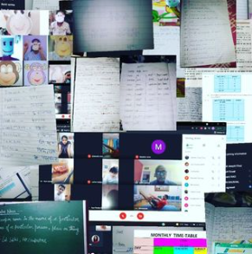
In the month of June, 2021, SUDHA Society started an online school for the underprivileged kids to give them better education opportunities. This initiative was taken by Ms. Deepti Goyal / Ms Pooja Bhardwaj , volunteers of SUDHA. All the volunteers who teach the kids are highly dedicated and qualified. As of today more than 70 poor children are studying online - all across India .

